UPLOAD AND PRINT LOGO

T CODE – SE78

GIVE THE NAME

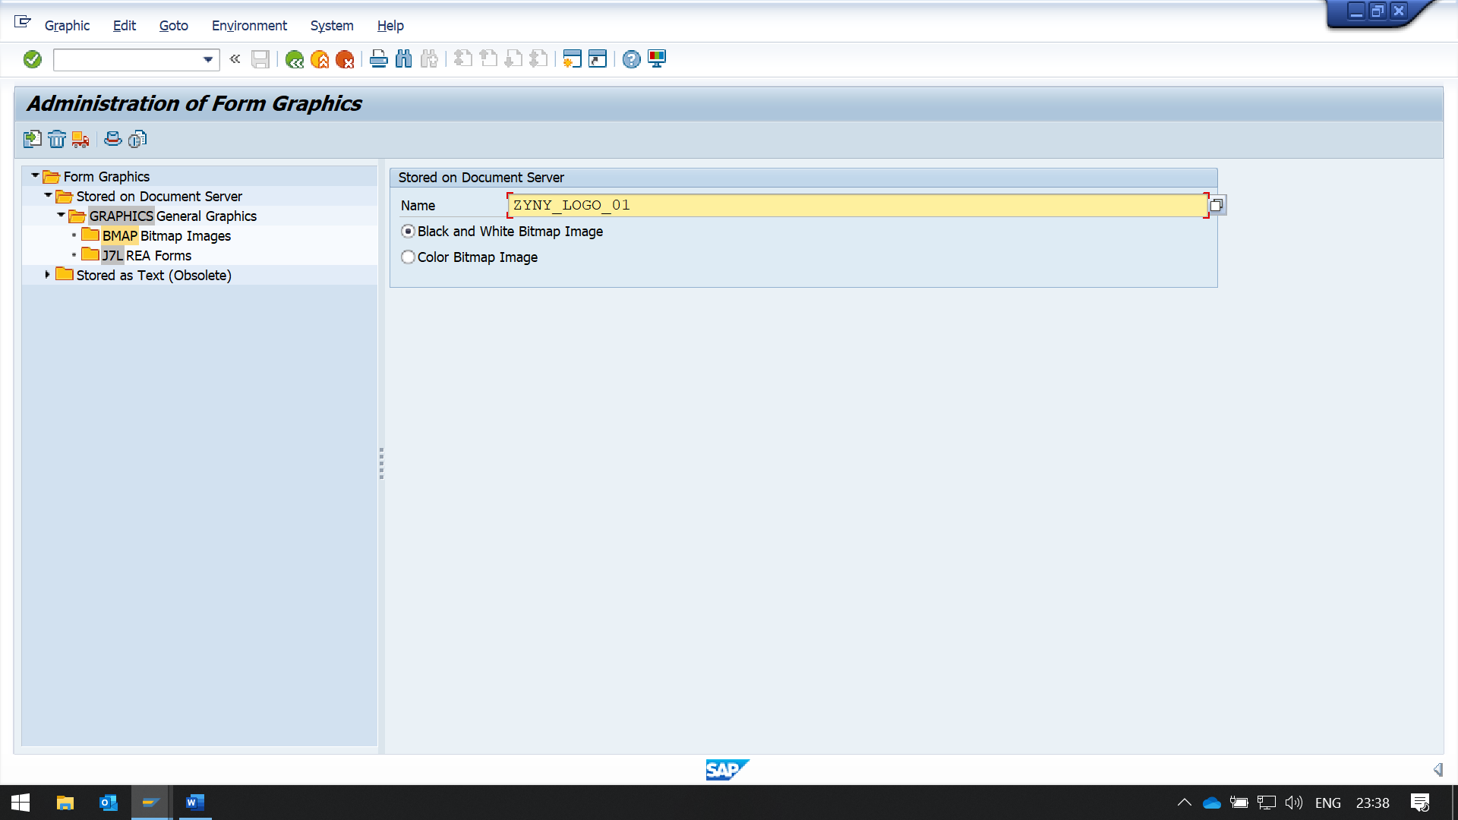

YOU CAN EITHER CHOOSE BLACK AND WHITE OR COLOR BMP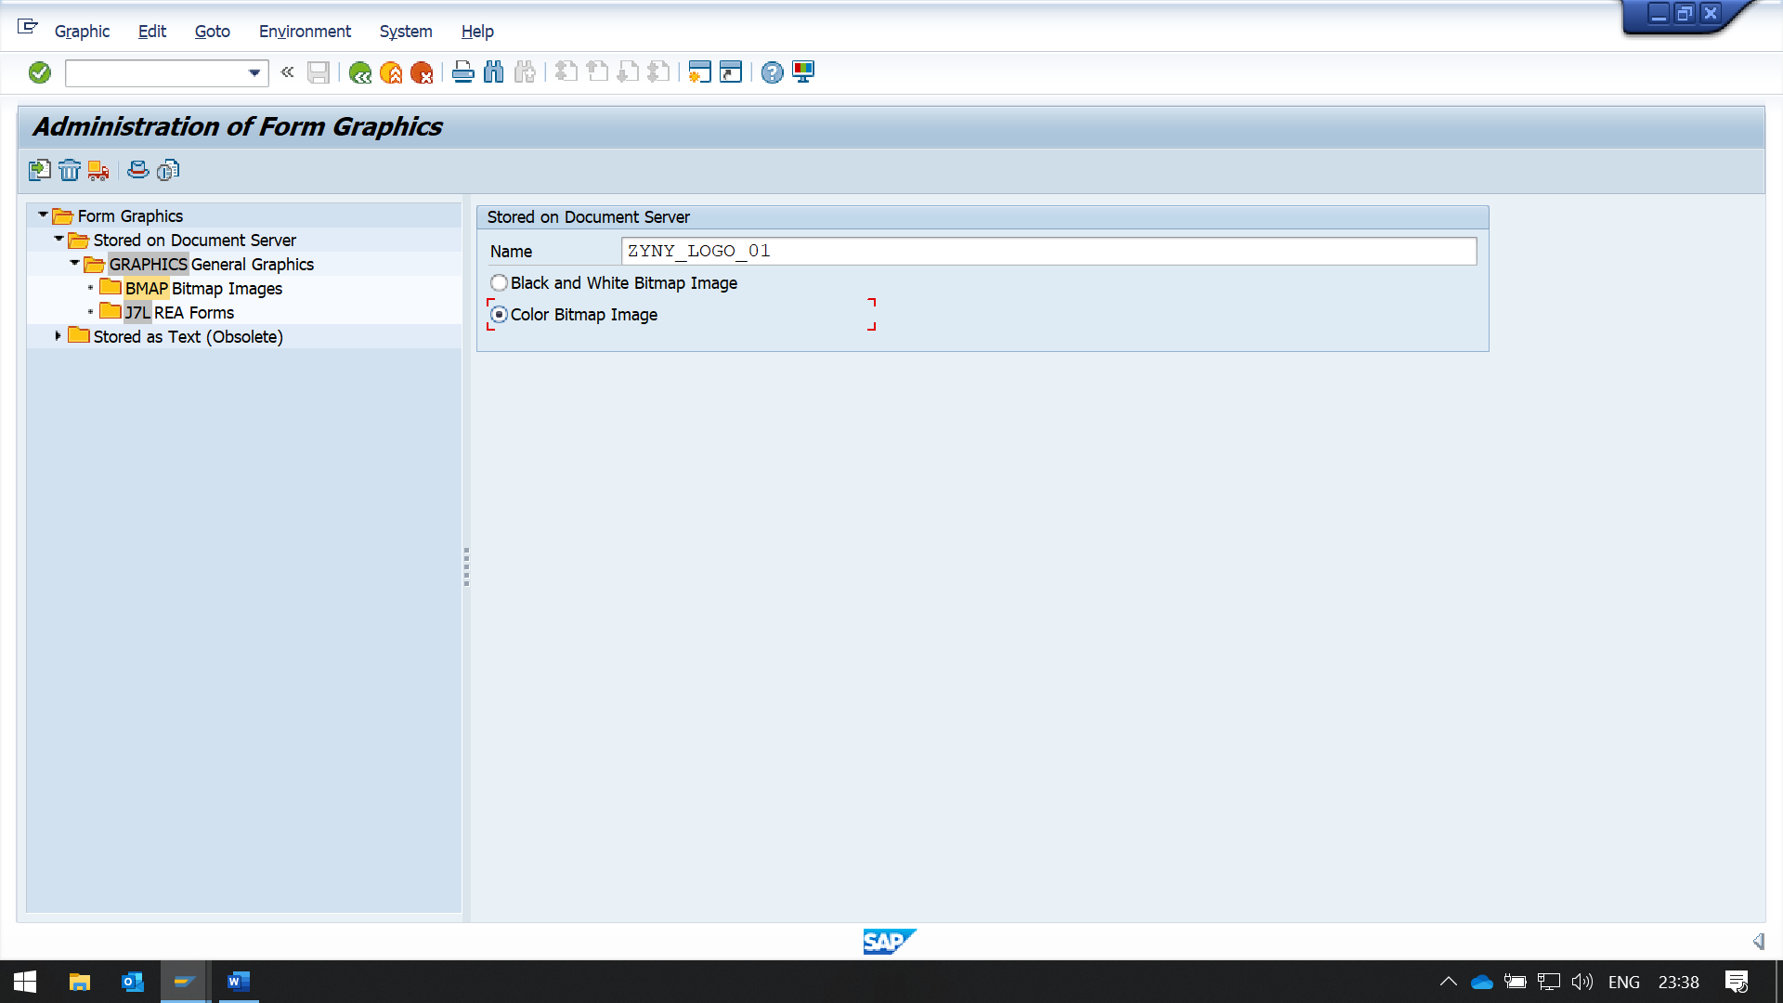

NOW CLICK ON THE IMPORT BUTTON IN TOOL BAR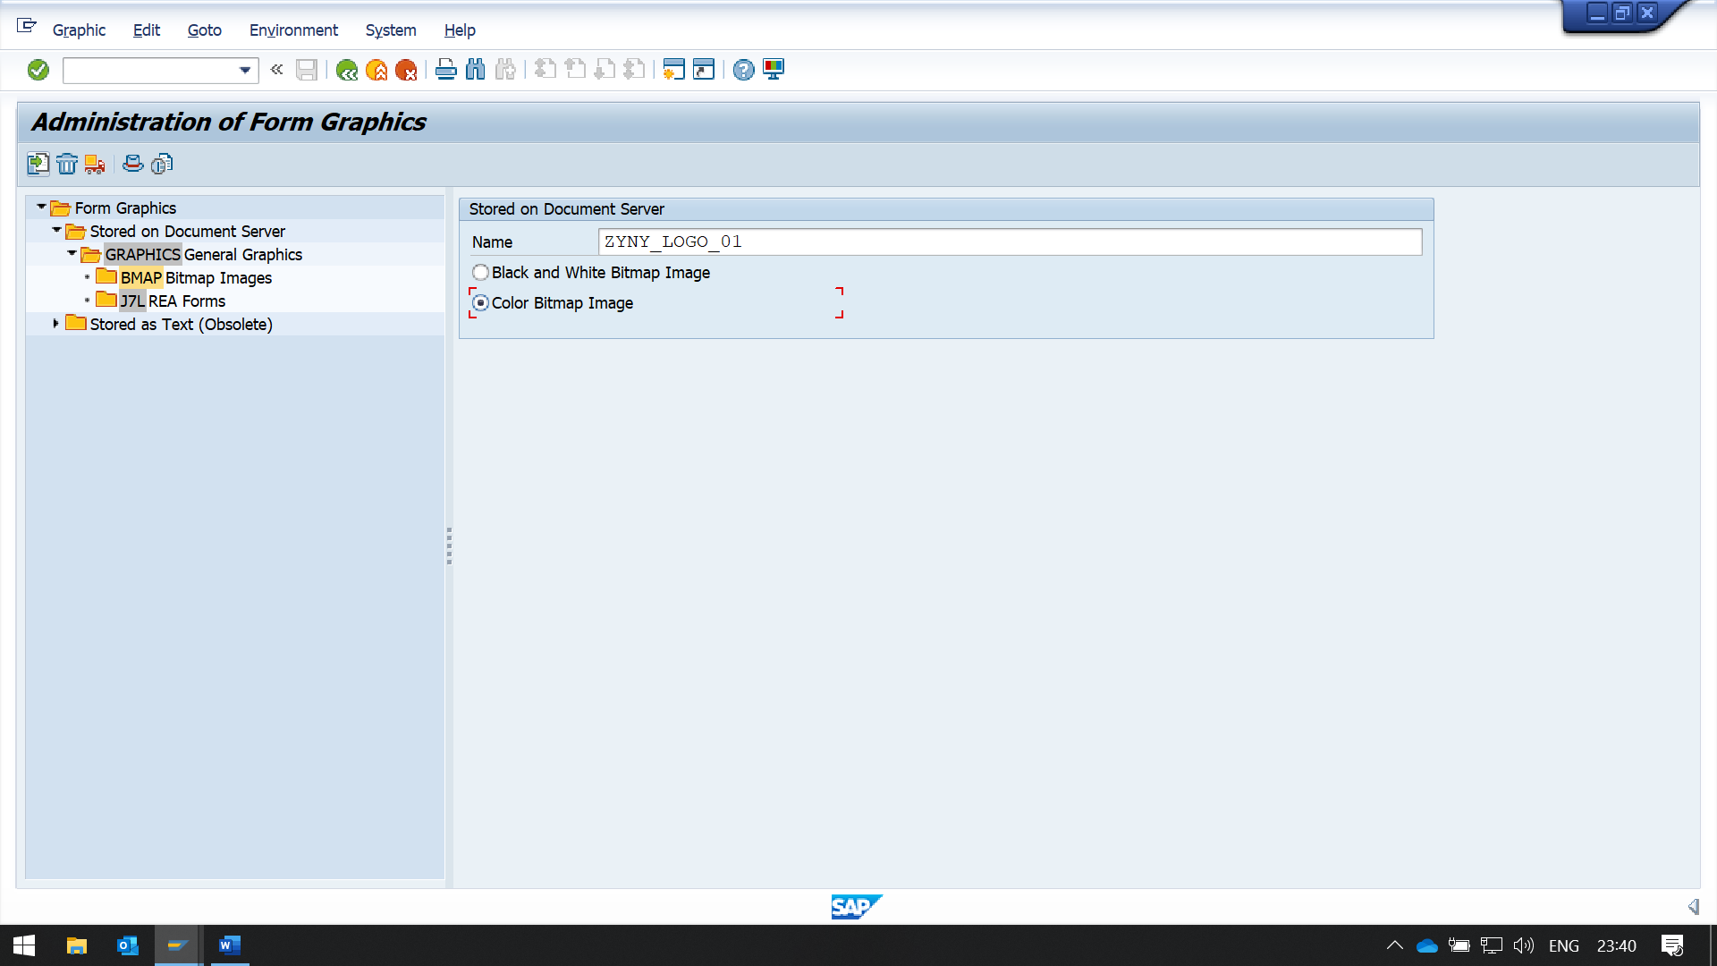

NOW ENTER THE FILE LOCATION OF THE BMP IMAGE

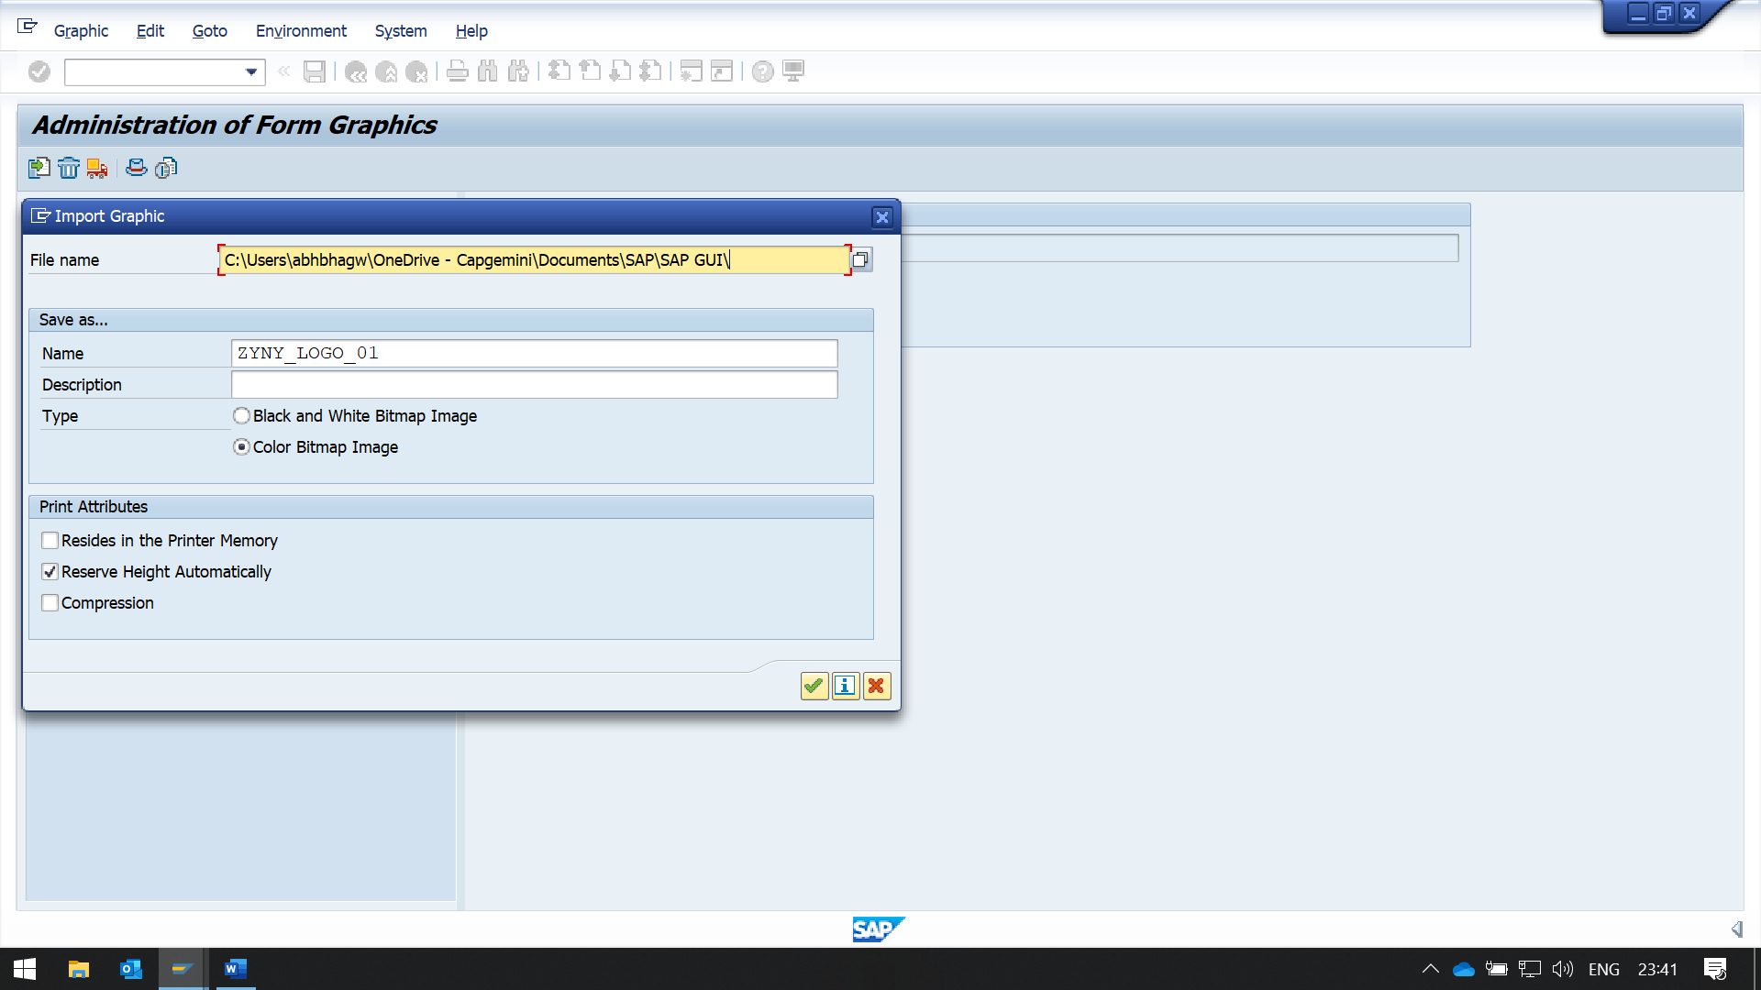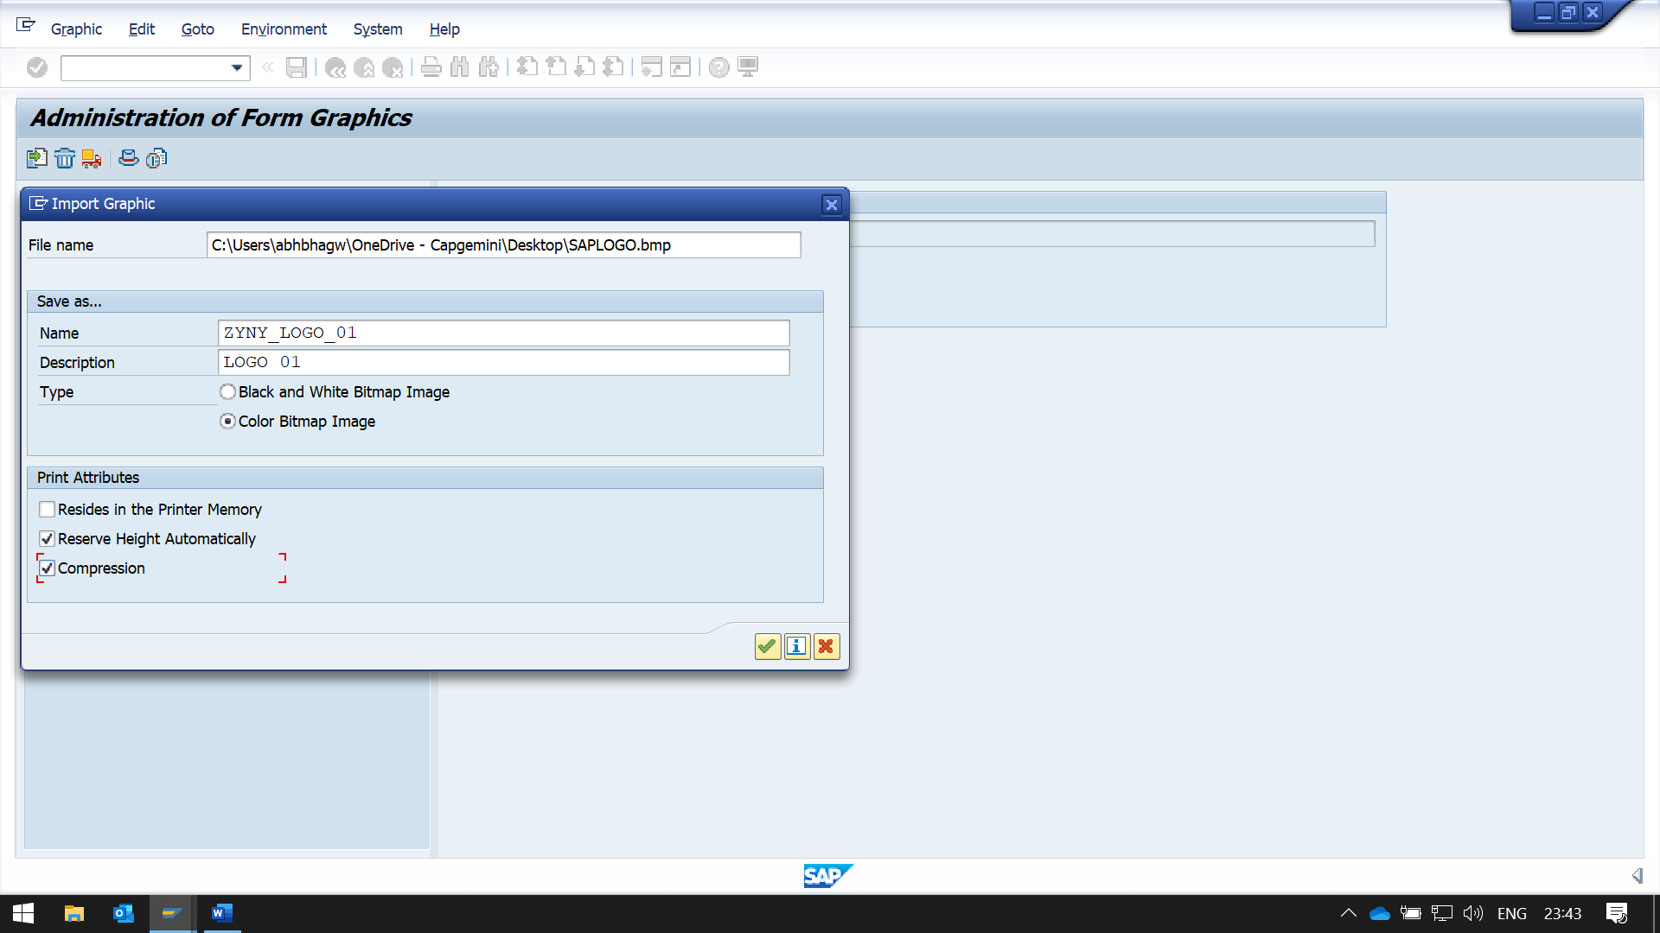

WHILE SAVING THE IMAGE

SYSYTEM DOES NOT ASK FOR REQUEST NUMBER

WE HAVE TO MANUALY DO THAT

CLICK ON THE TRANSPORT BUTTON IN THE TOOL BAR

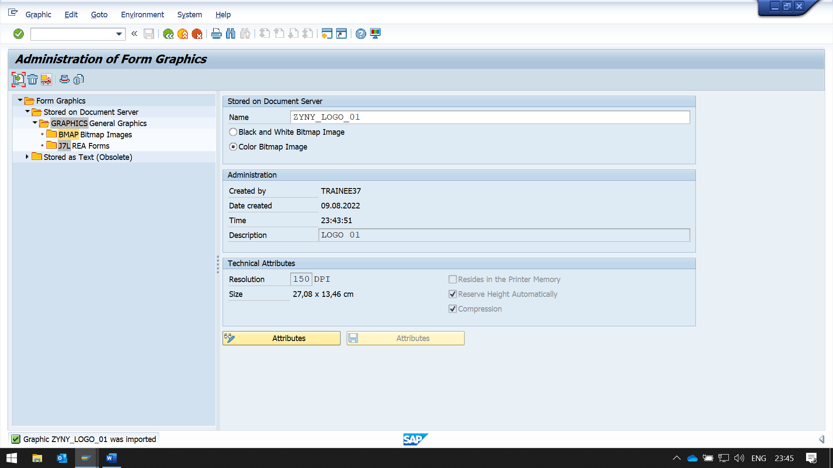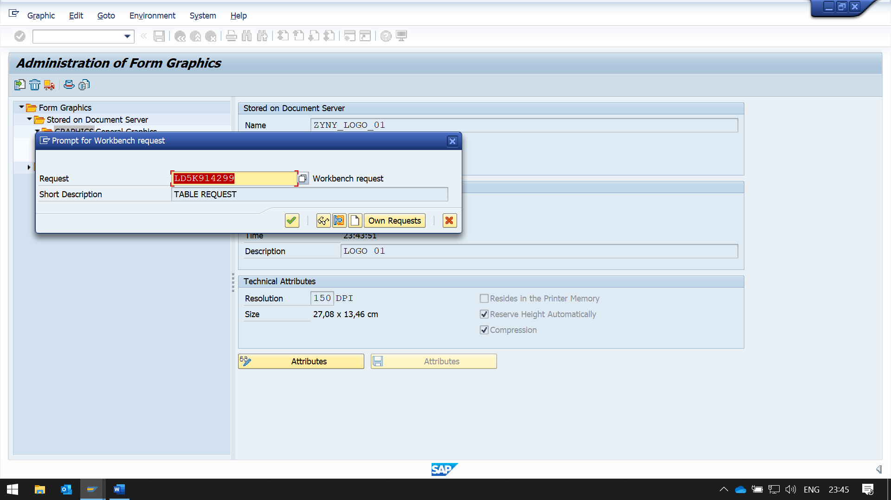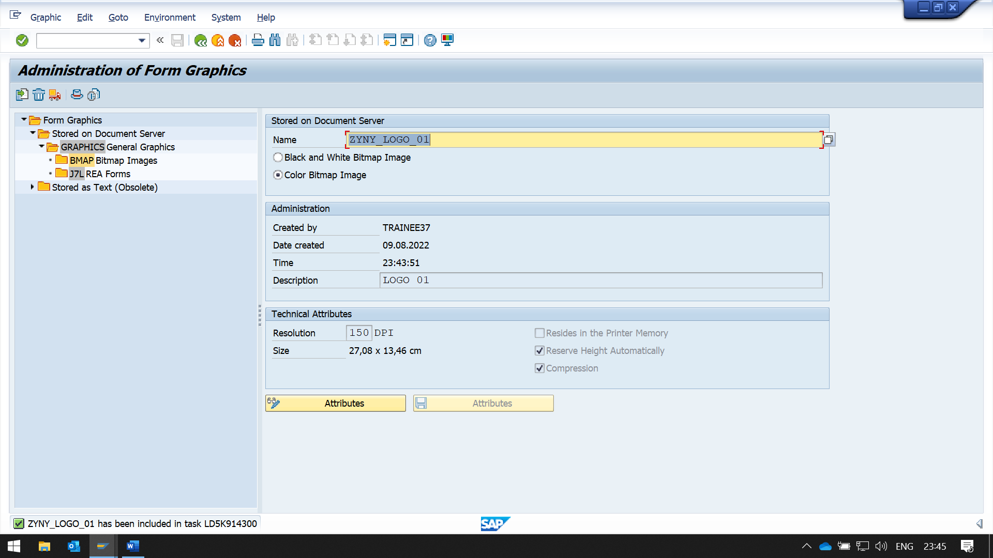

YOU CAN CHECK YOUR IMAGE USING PRINT PREVIEW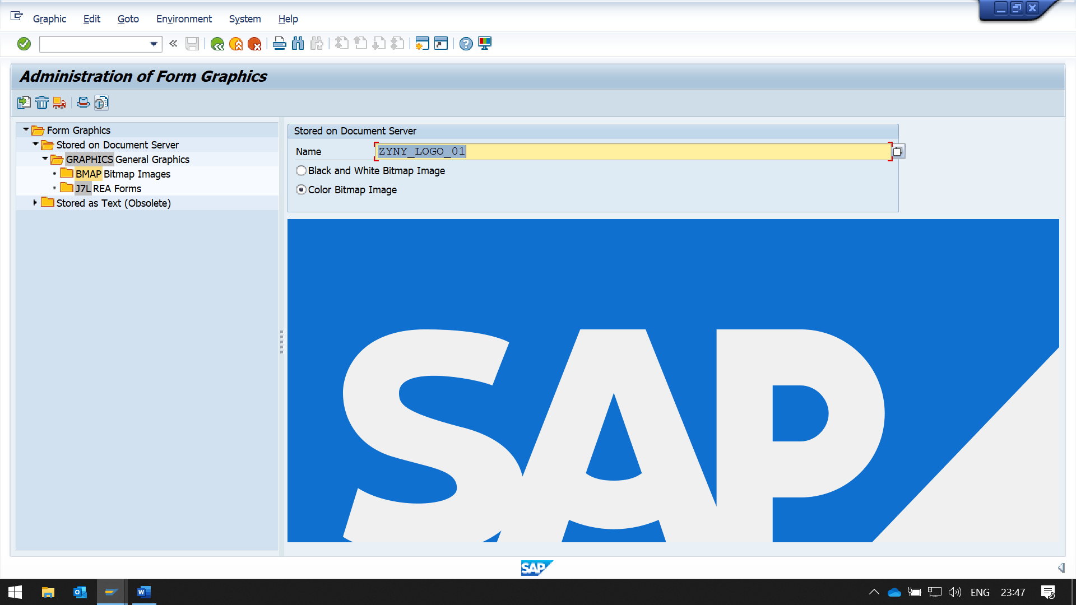

CRAETE A FORM THEN IN WINDOW ADD A GRAPHIC

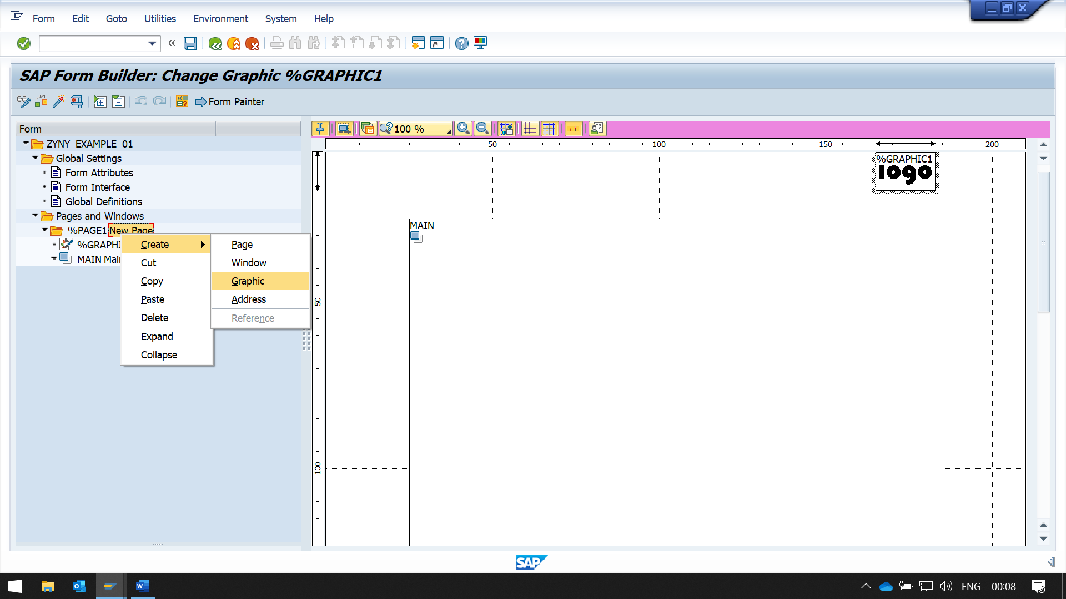

NOW ENTER THE GRAPHIC NAME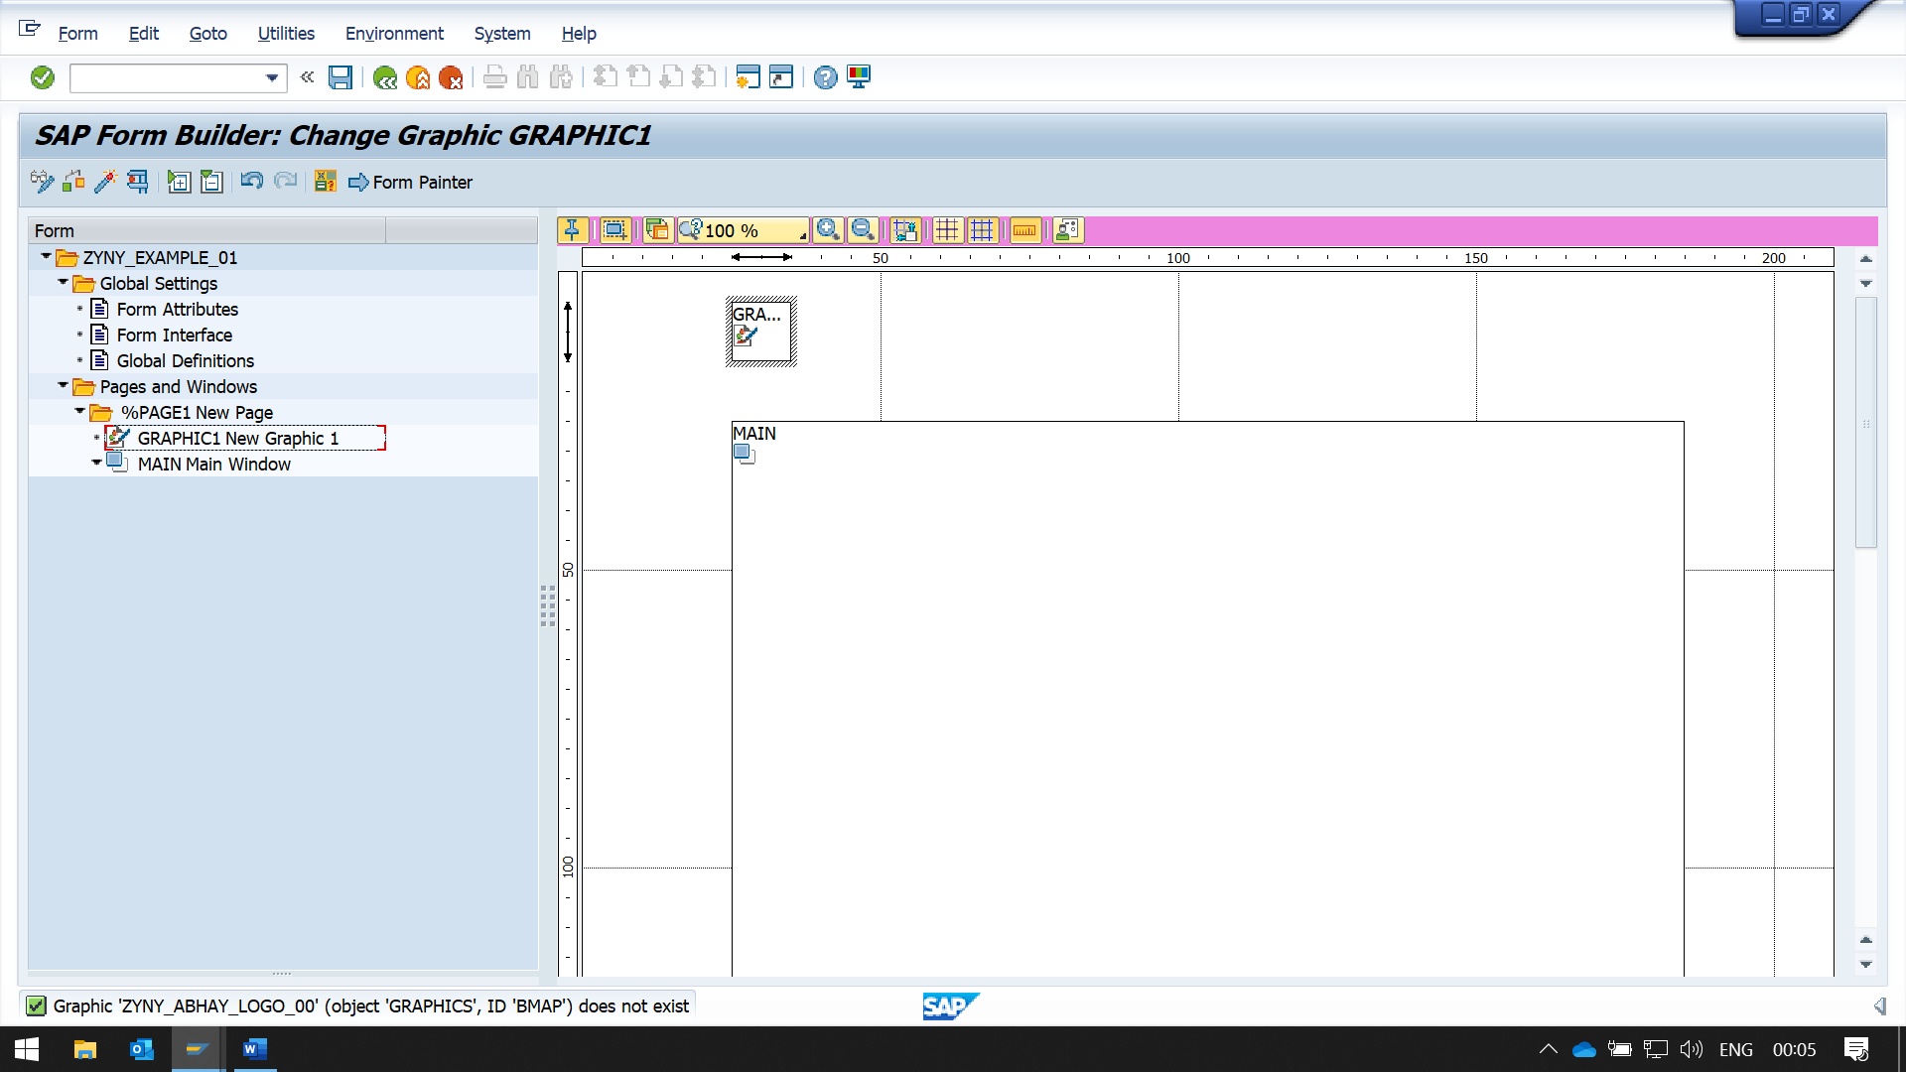

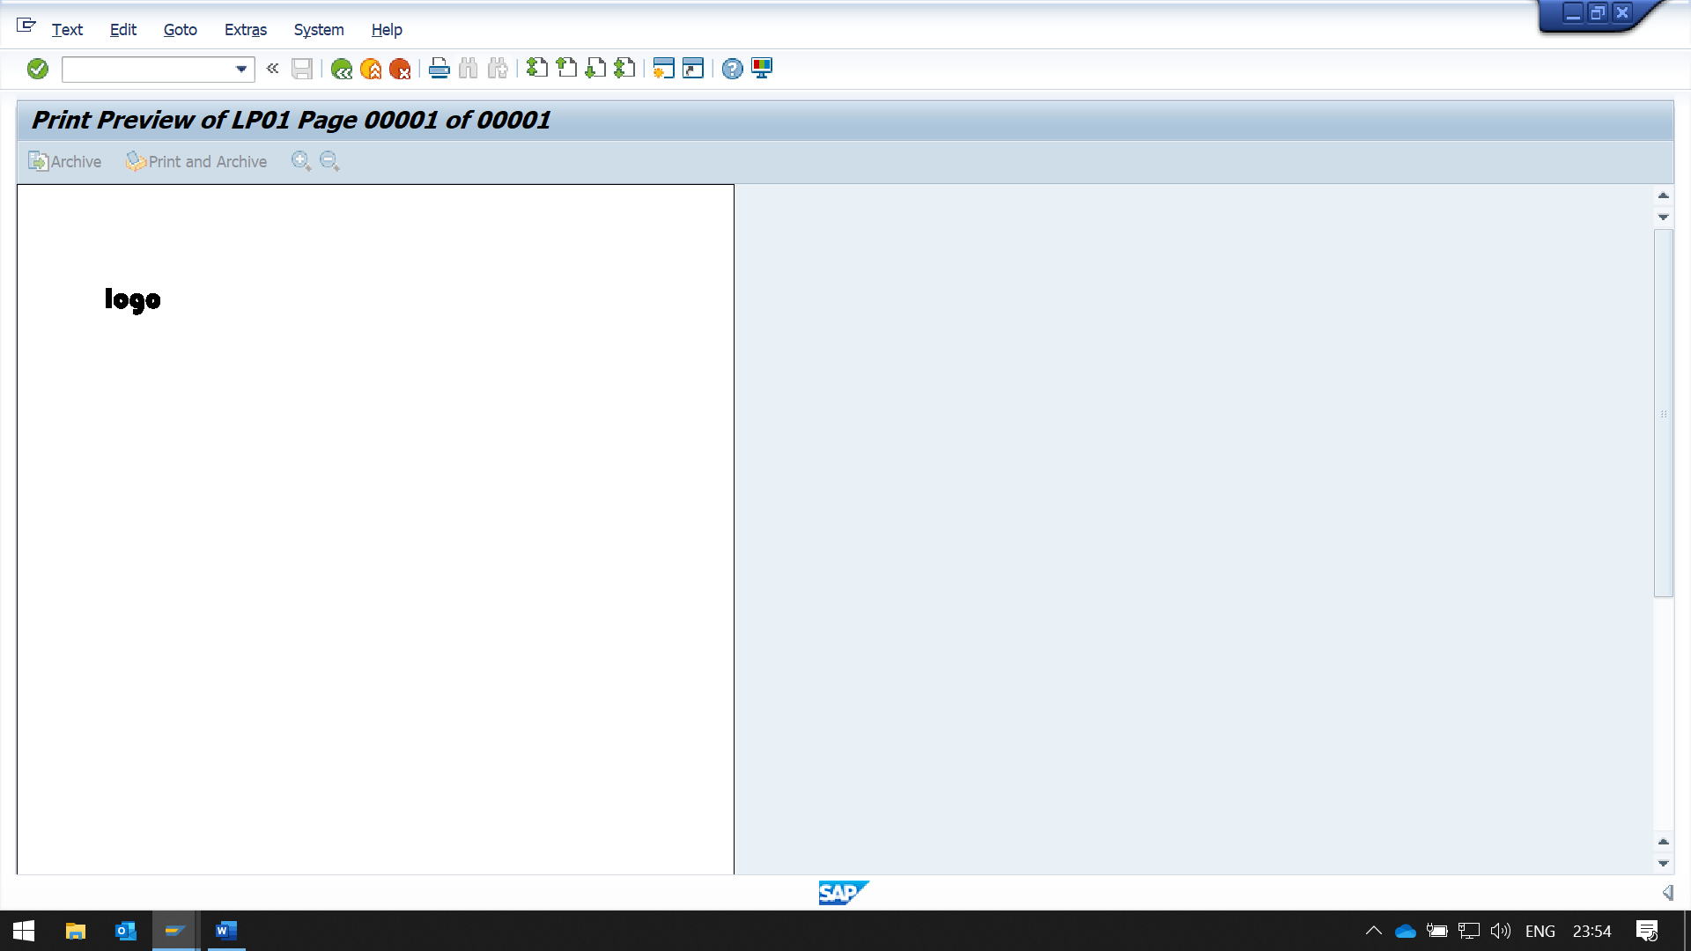

BY USING FORM PAINTER, WE CAN ADJUST THE MARGIN OR ALIGMENT OF THE IMAGE

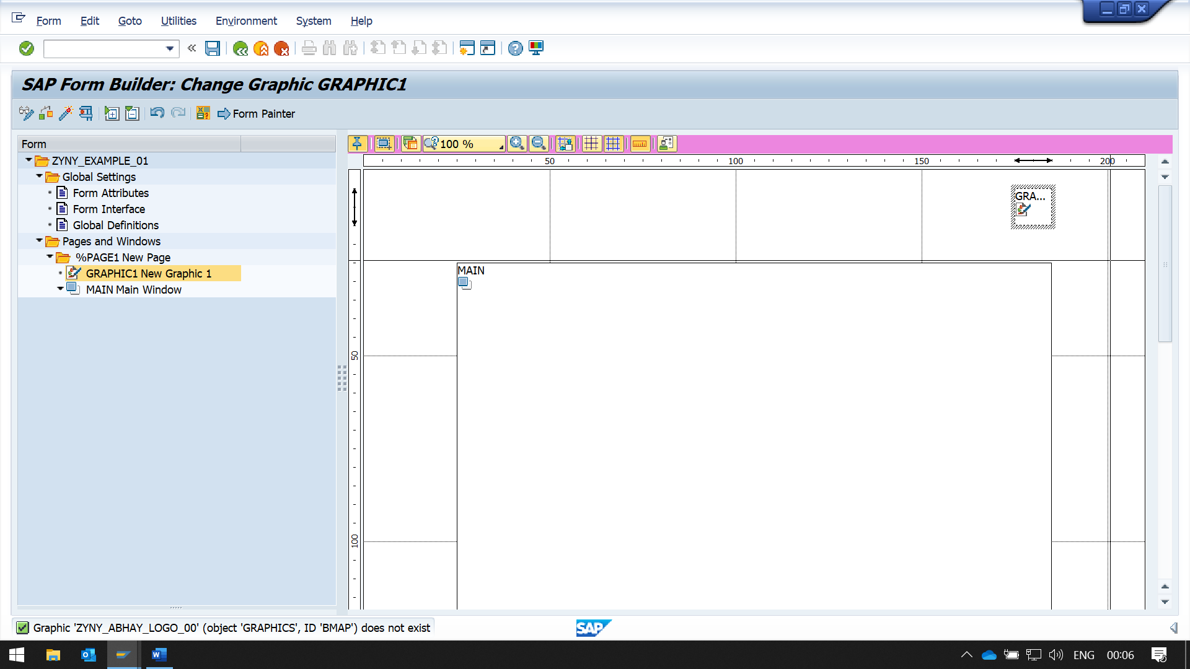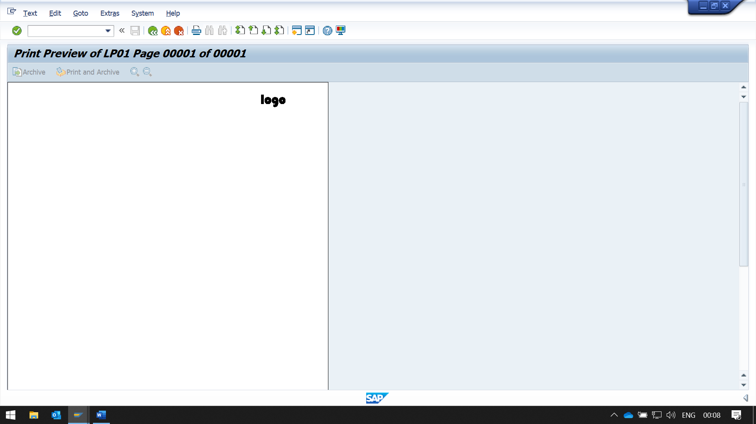

CAN ALSO USE THE LEFT MARGIN AND UPPER MARGIN FIELDS IN OUTPUT OPTIONS

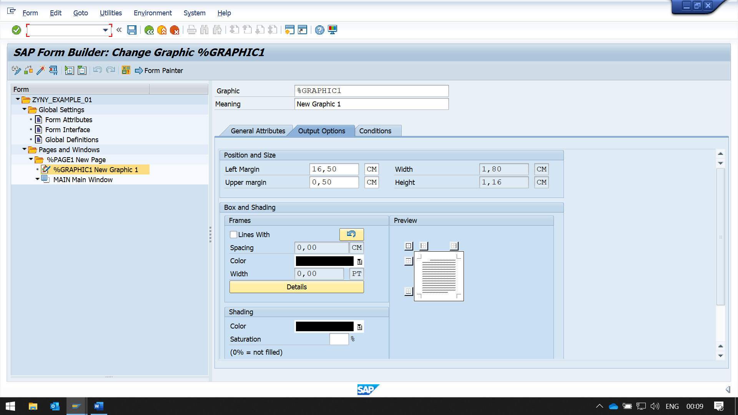

NOW TO CREATE A DYNAMIC TABLE

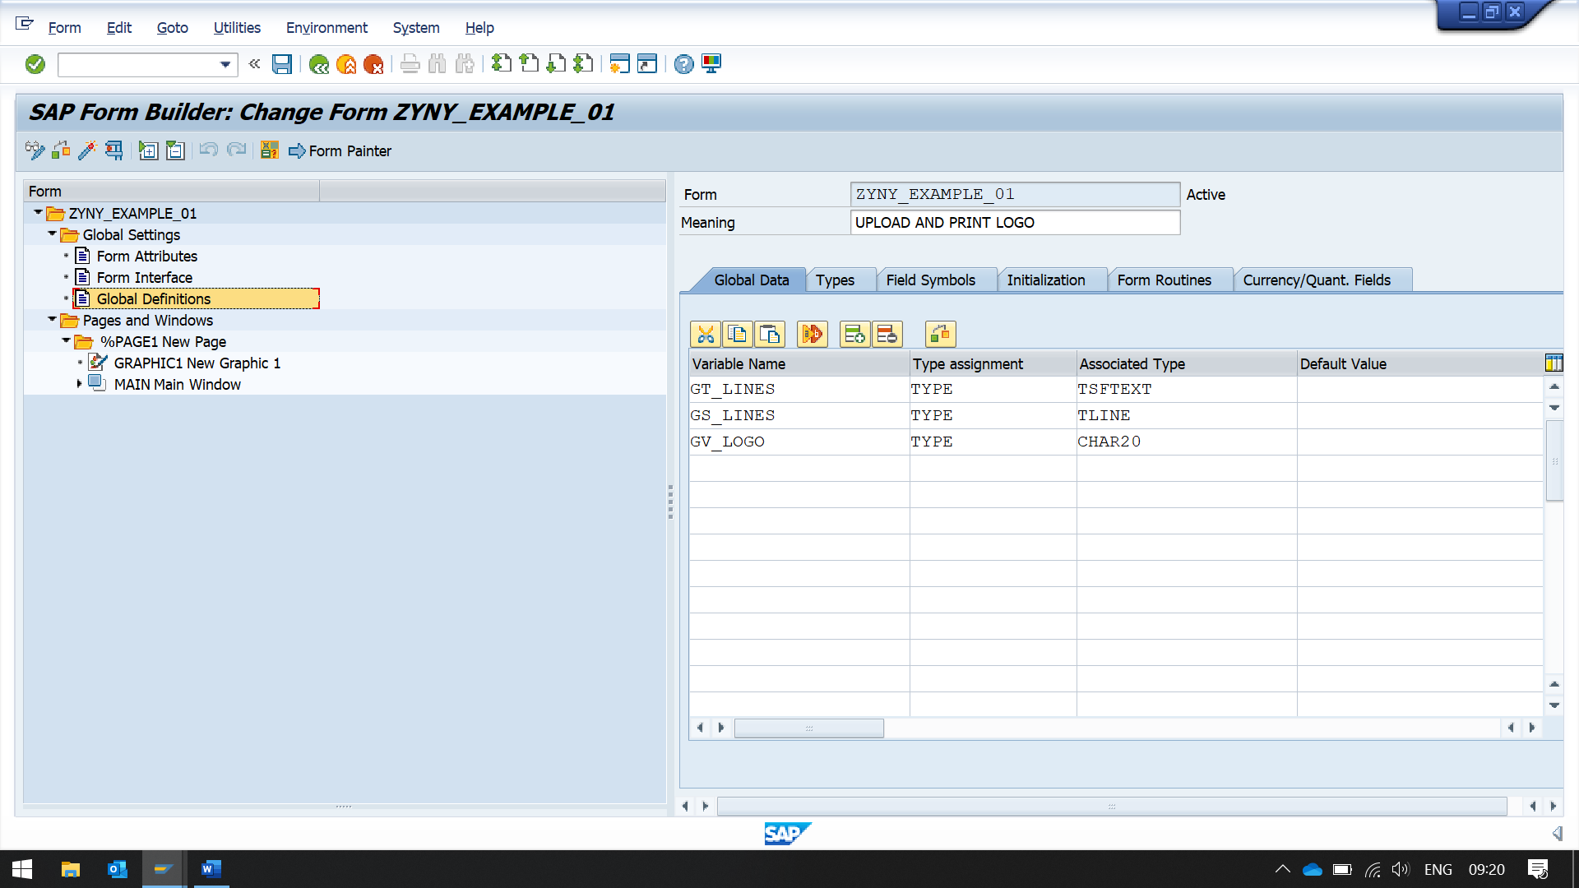

CREATE A VARIABLE IN GLOBAL DEFINITIONS TO PASS THE NAME IF THE LOGO IMAGE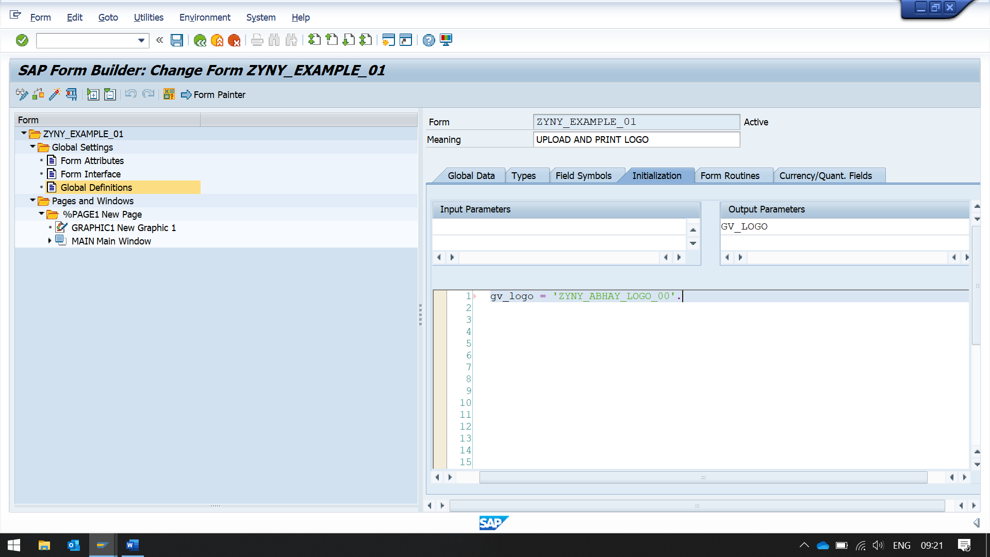

IN INITIALIZATION BLOCK, INITIALIZE THE BLOCK WITH NAME OF LOGO

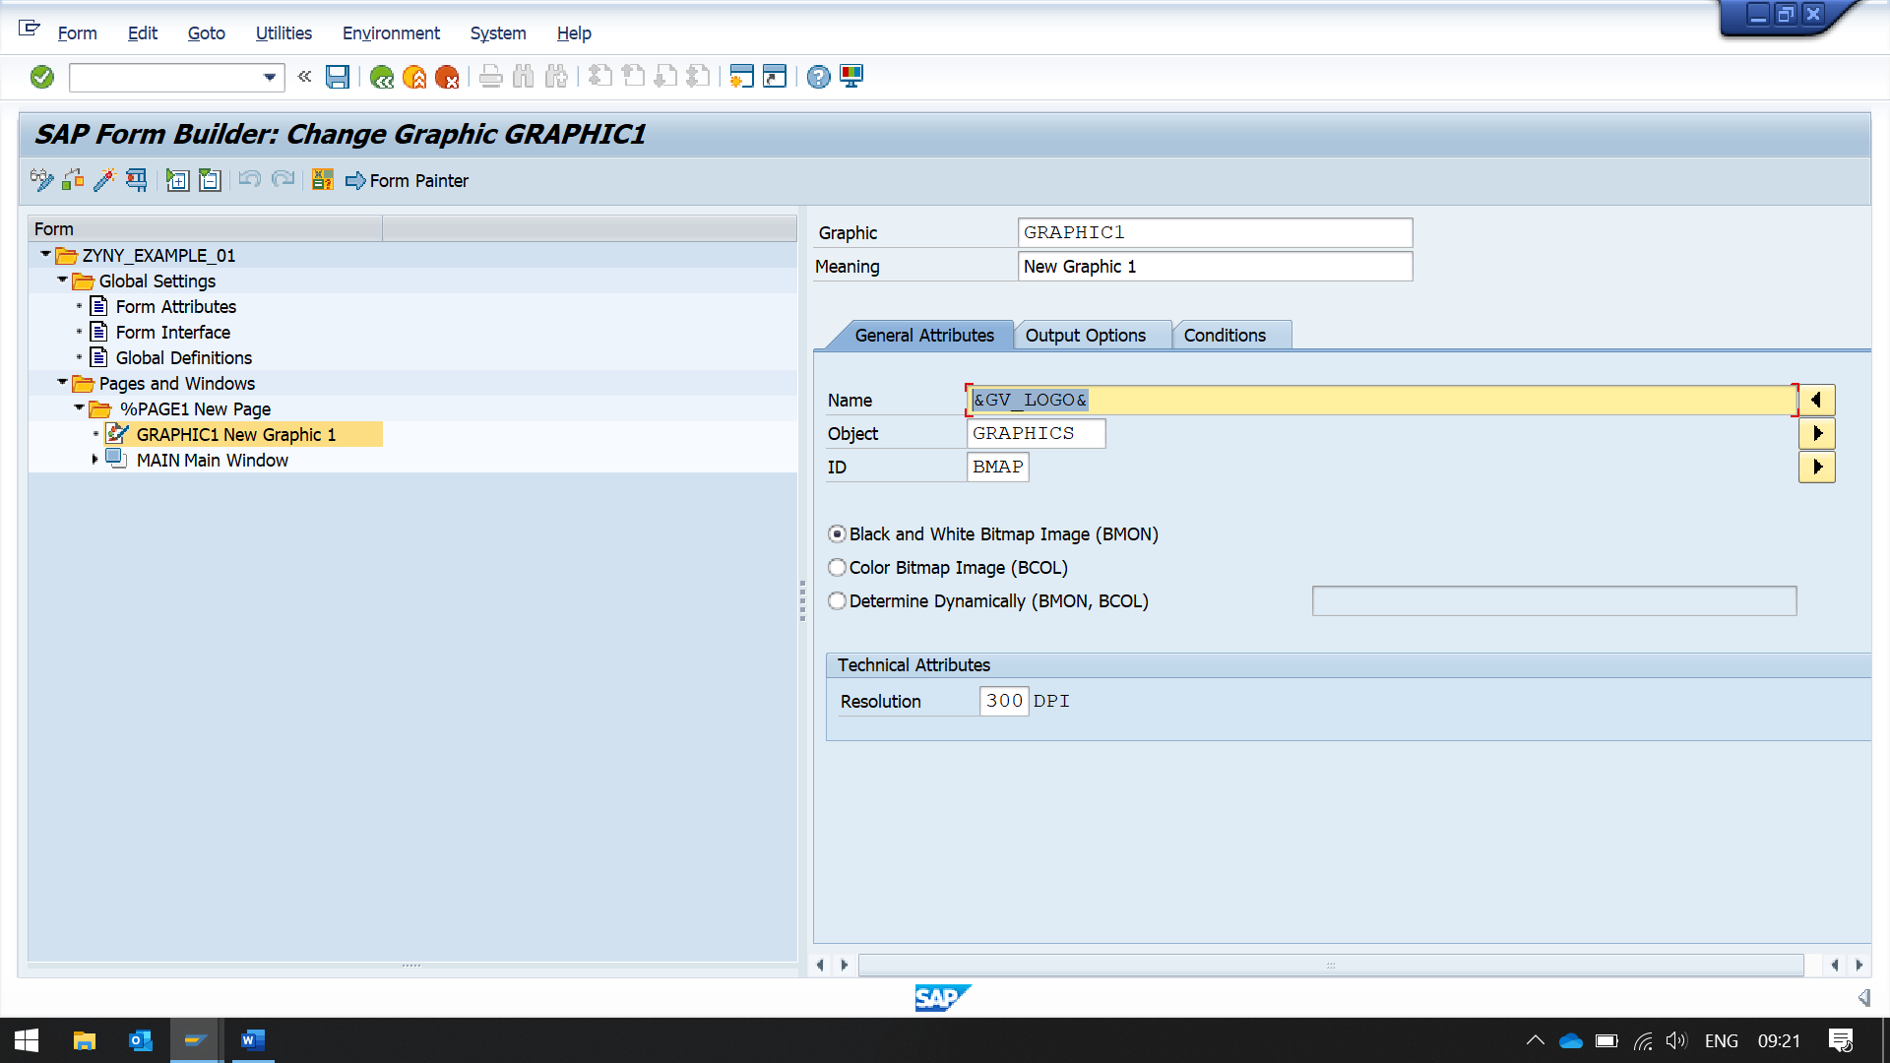IN GENERAL ATTRIBUTES TAB OF GRAPHICS, IN NAME FIELD ENTER THE VARIABLE NAME WITH &.

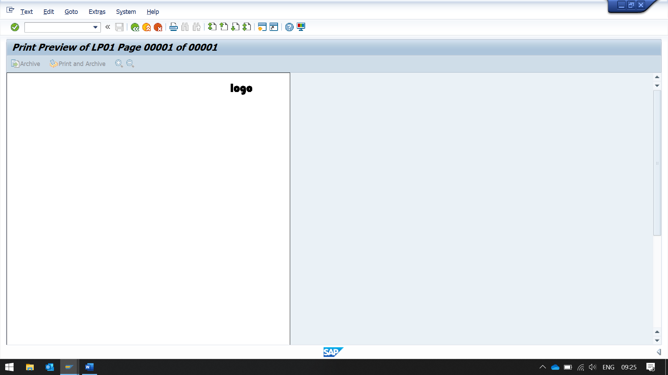SAVE AND ACTIVATE

FOR BACKGROUN IMAGE

GO TO PAGE -> BACK GROUND PICTURE TAB

IN NAME FIELD, ENTER THE NAME OF THE GRAPHS WHICH CONSTAINS IMAGE

HERE IF OUTPUT MODE IF SELECTED AS PRINT PREVIEW

IT WILL ONLY SHOW BACKGROUND IMAGE, BUT NOT ACTUALLY PRINT THE IMAGE ON THE OUTPUT SCREEN ( OUTPUT SCREEN MEANS ACTUAL PRINT)

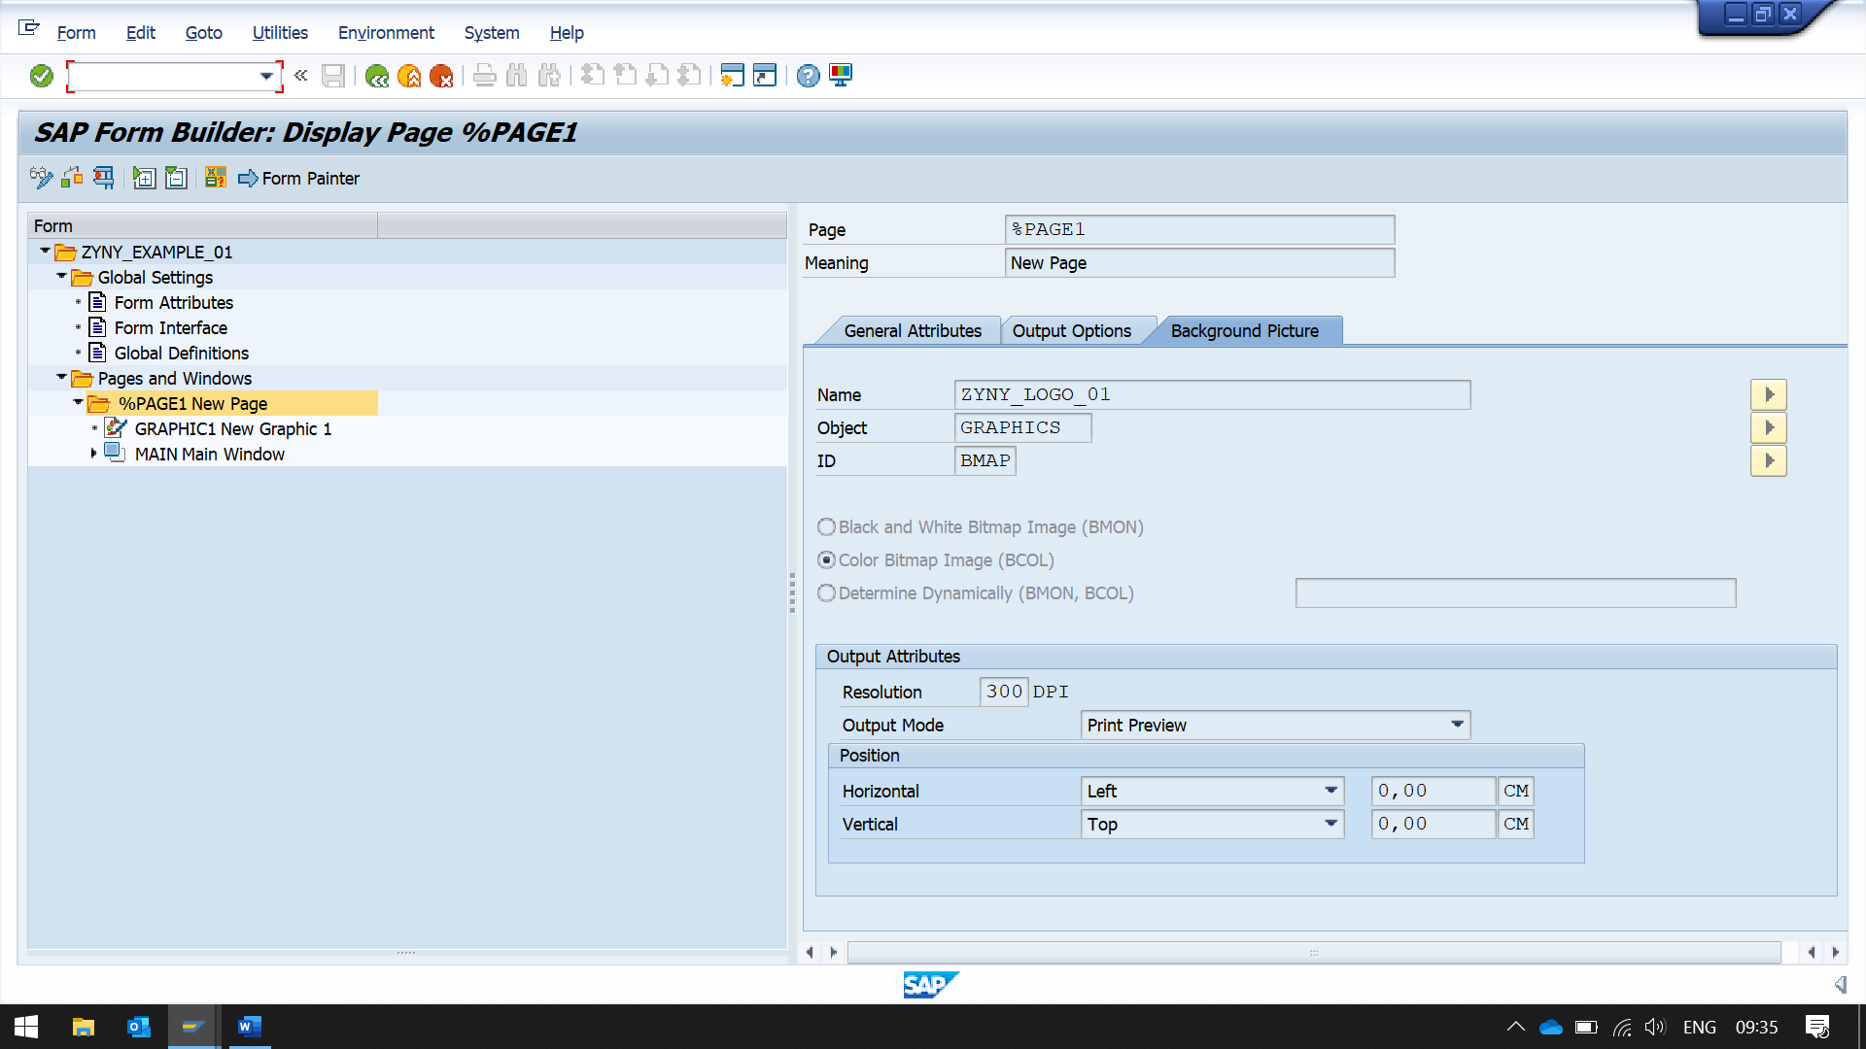

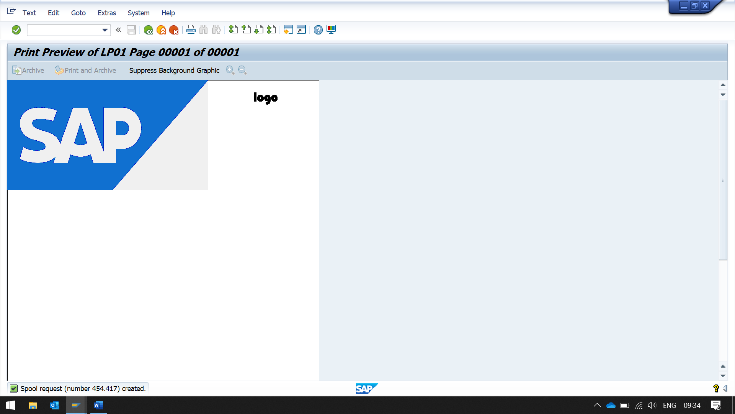

BUT BY SELECTING OUTPUT MODE AS PRINT PREVIEW AND PRINT, IT WILL PRINT IMAGE IN ACTUAL PRINT

